Our 2019 Thanksgiving at Dave & Michelle’s Home in Stow, MA.

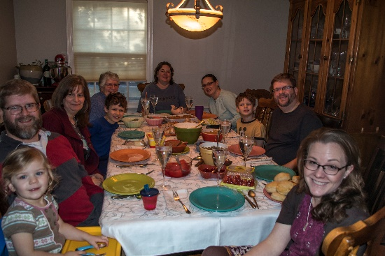Thanksgiving Day is the annual holiday commemorating the harvest festival celebrated by the Pilgrims in 1621, and is held in our country on the fourth Thursday in November.

Our family members gathered again at Dave & Michelle’s home in Stow and were joined by Michelle’s sister, Jen. We all enjoyed Dave & Michelle’s hospitality as we celebrated the day.

And for the photos, click [2019 Thanksgiving](https://photos.app.goo.gl/ATLd7ZhkGDErYWTF7). You are encouraged to “Zoom”.